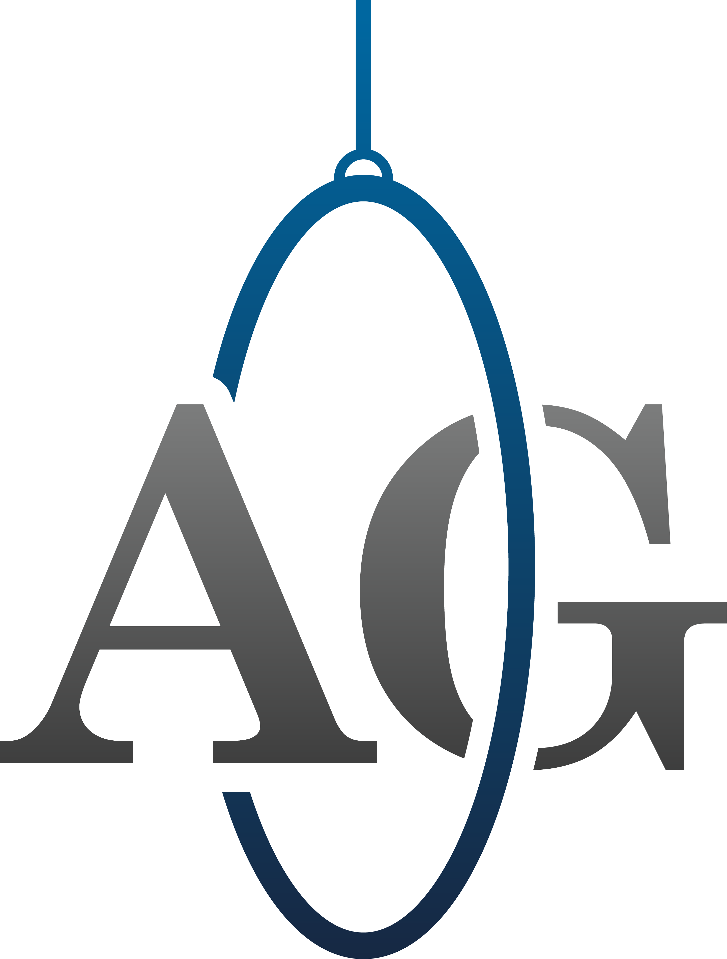
Aerial Gymnastics London Ltd

Membership number:

Parent or Guardian Details

Full Name:

Address (If Different to Gymnast)

Mobile Number:

Email address:

Emergency Contact Number:

Medical Conditions:

Epilepsy YES/NO Nose Bleeds YES/NO Asthma YES/NO Blood Disorder YES/NO Fits YES/NO Diabetes YES/NO
Plasters YES/NO Chalk YES/NO Penicillin YES/NO
Allergies:
Others (Please Specify)

Details:

Name of Child:

Date of Birth:

First Line of Address:

Post Code:

Aerial Gymnastics London Terms & Conditions

Please carefully read and sign the following terms and conditions to express your understanding of these rules and to confirm that they will be followed. Breaking our terms or conditions may result in loss of place and/or withdrawal from the club.

- Children who arrive more than 15 minutes late will not be able to participate in the class. The first 15mins of class is dedicated to warm up, which is essential for injury prevention during the lesson.
- There will be no photography/video of classes. This is in adherence to the right to protect the images of all the children as well as coaches.
- The children must wear appropriate clothing. This means tight fitting, flexible clothing, which allows for full cover/protection, such as: leotards, leggings, jogging bottoms, t-shirts etc. No jeans, hoodies, shoes, skirts, vests, or anything that may cover the face once upside down. (Please note, backs of knees must be covered at all times.)
- Absolutely no jewellery is permitted under any circumstances.
- Lost property will be given to ELGC and will be held for a maximum time of one month.
- AGL is not responsible for the protection of individual’s personal items; all items brought into the studio are at the individual’s own risk.
- Parents are to arrive 5 – 10 minutes before the end of each session to collect their child(ren).
- Please remember that renewals must be paid in advance of the following term. The due dates for fees are always on the 23rd of the last month of term (for example, January’s term’s fees are always due by the 23rd of the December)
- We do not accept late fees, if fees are overdue, this may result in loss of space. If you are away, or unable to make the payment before the deadline, you must notify Nathalie Alison at info@aerialgymnasticslondon.co.uk.
- No food or drink (apart from water) is to be brought into the studio.
- Membership and fees are non-refundable.

Kind regards,

AGL Management
Parent/Guardian:

Signed:

Print:

Date:

www.aerialgymnasticslondon.co.uk
info@aerialgymnasticslondon.co.uk
+447477804630

